# CSE3501-Information Security Analysis and Audit

# Lab 9+10

# Lab FAT

# Submitted by: Alokam Nikhitha

# Reg No:19BCE2555

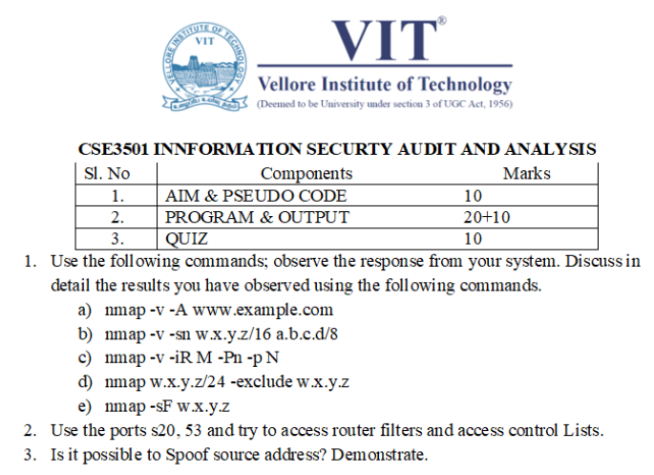

1)

AIM

To run the Nmap commands and observe the detailed results

PROGRAM & OUTPUT:

A) nmap –v –A [www.google.com](https://www.google.com)

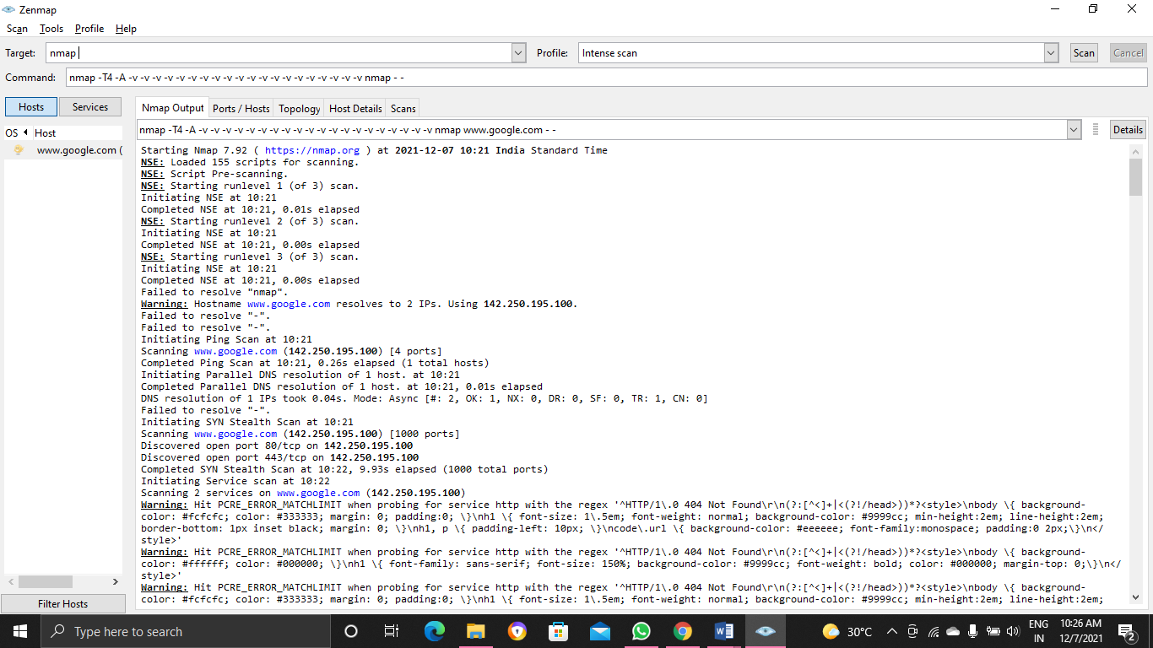 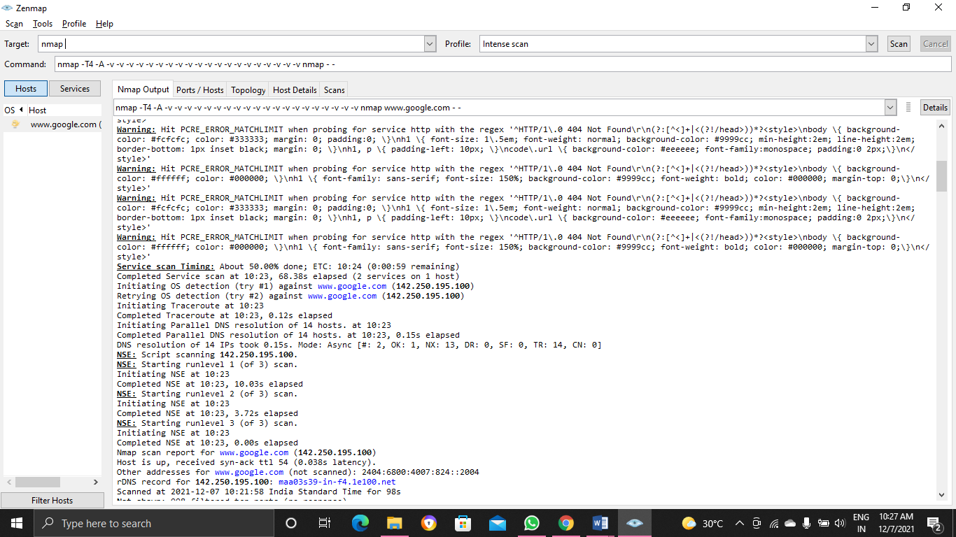

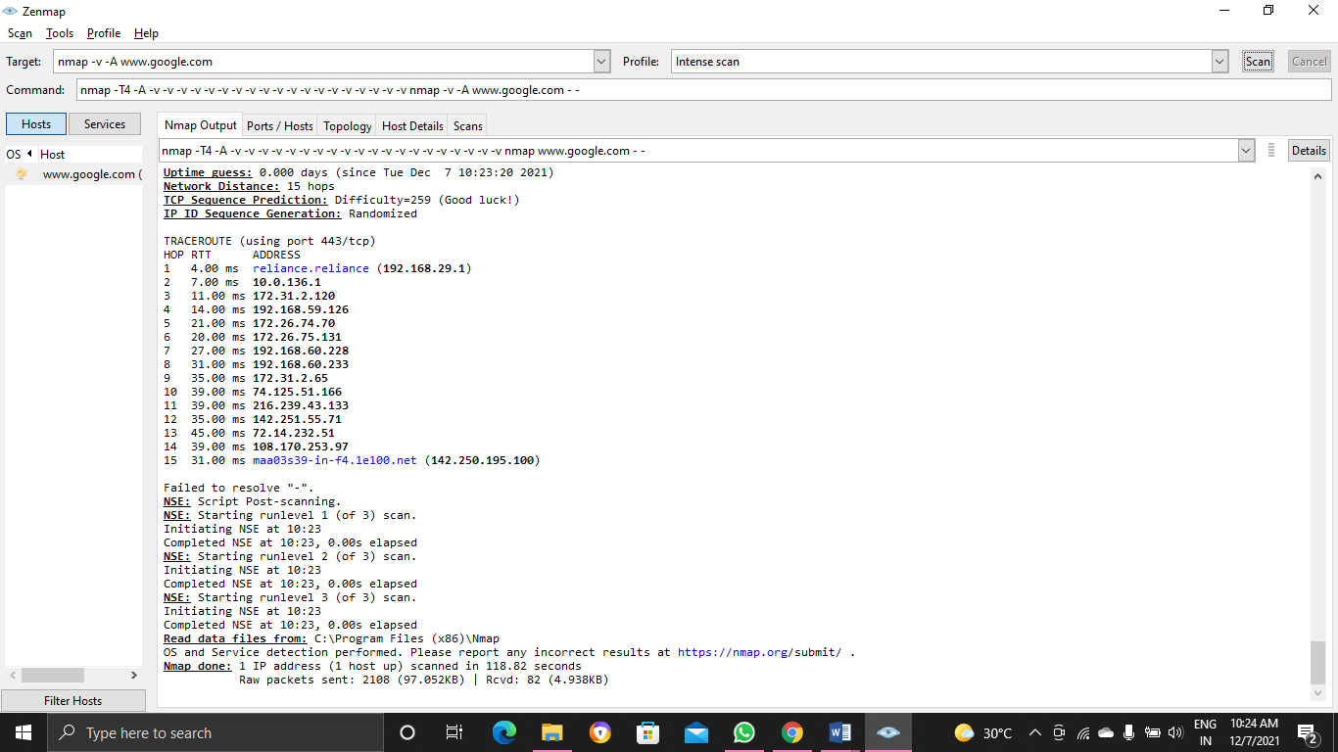

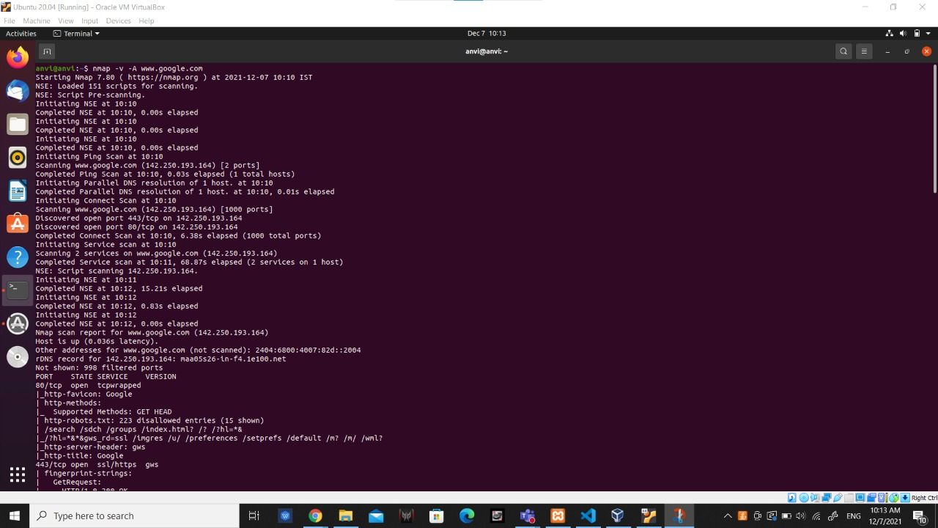

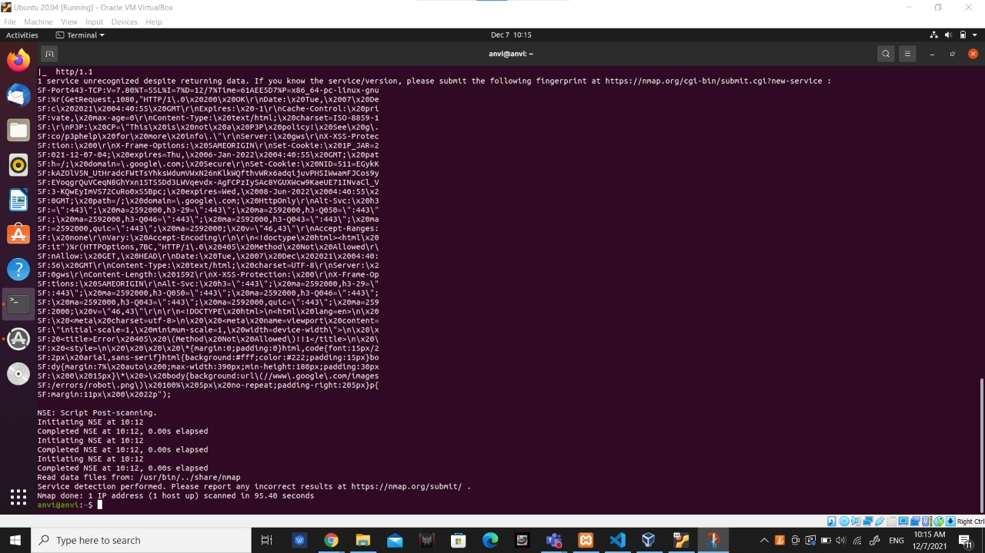

b)nmap –v –sn 10.0.2.255/16 127.0.0.1/8

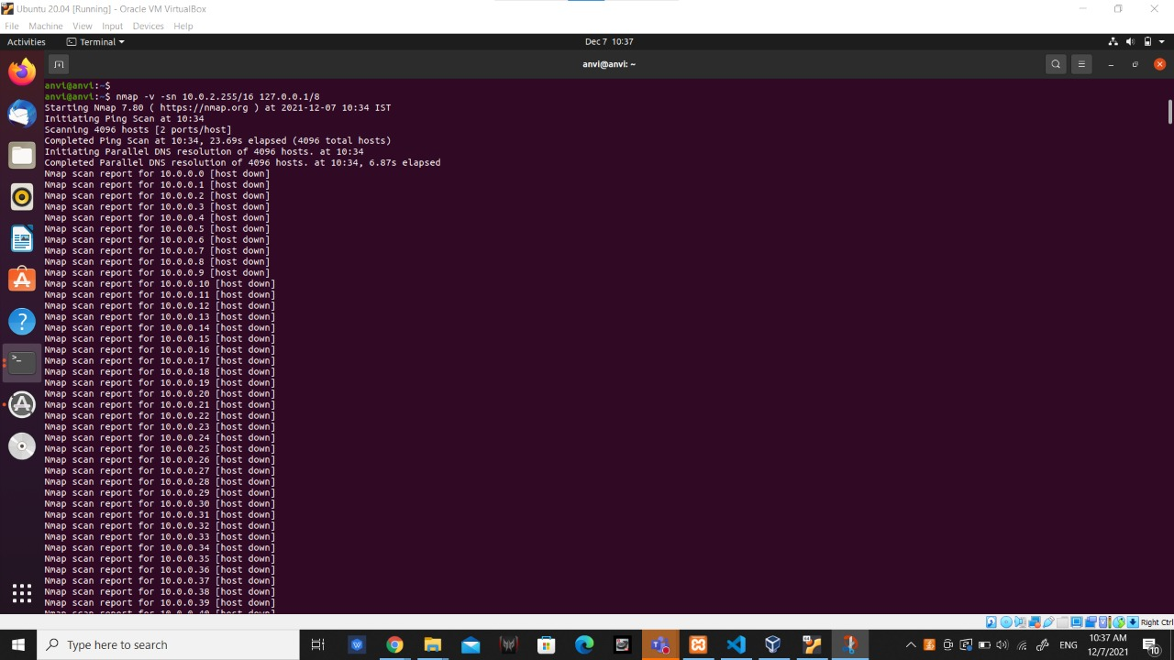

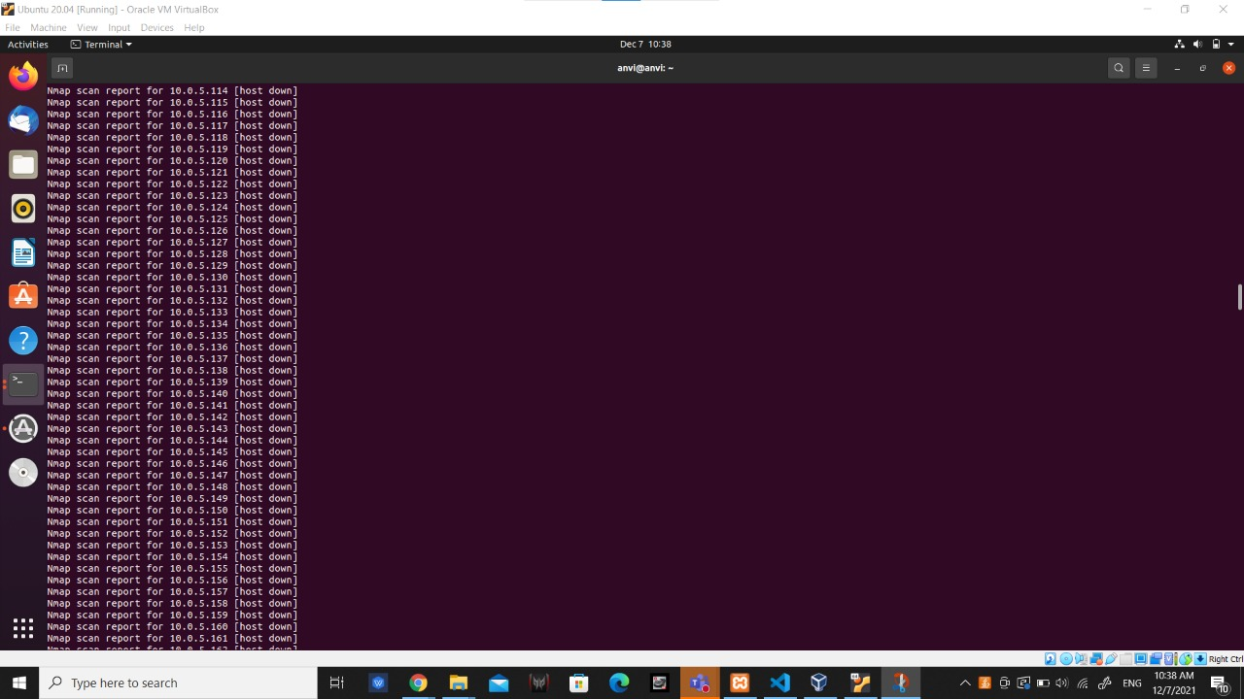

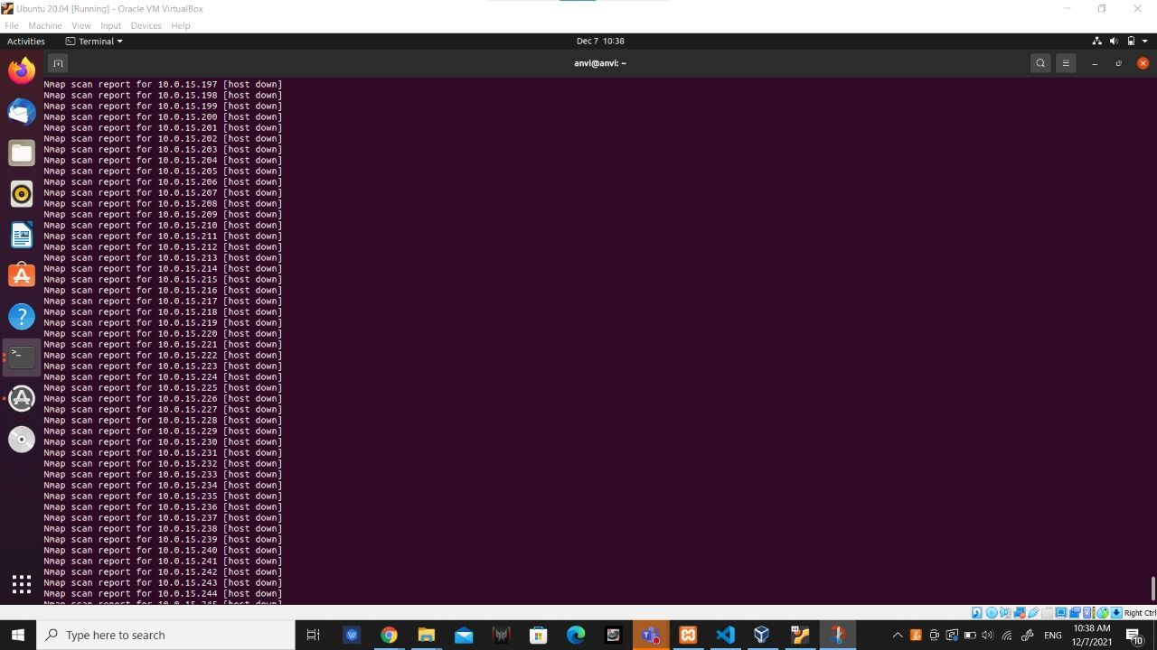

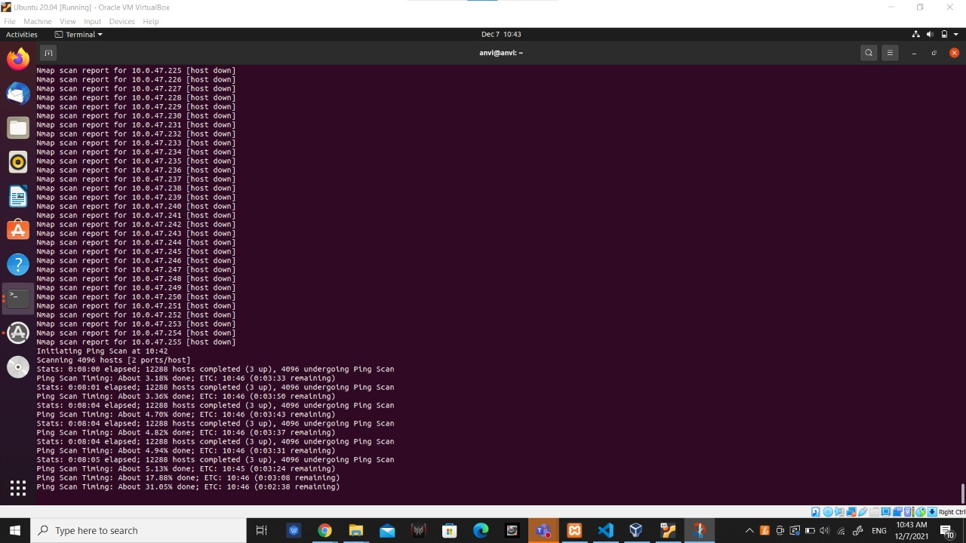

c) nmap -v -iR M -Pn -p N

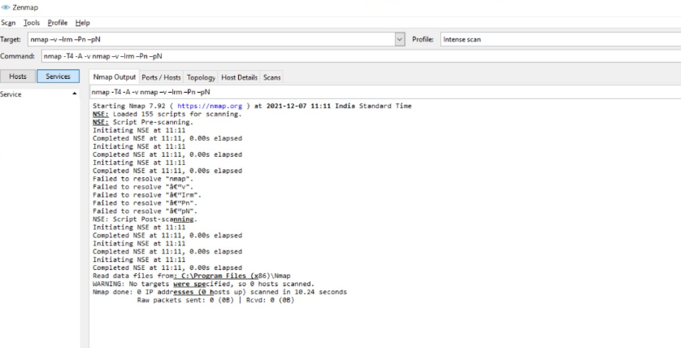

d)nmap 127.0.0.1/24 -exclude 127.0.0.3

Here we excluded 127.0.0.3 port from series can see in the image below

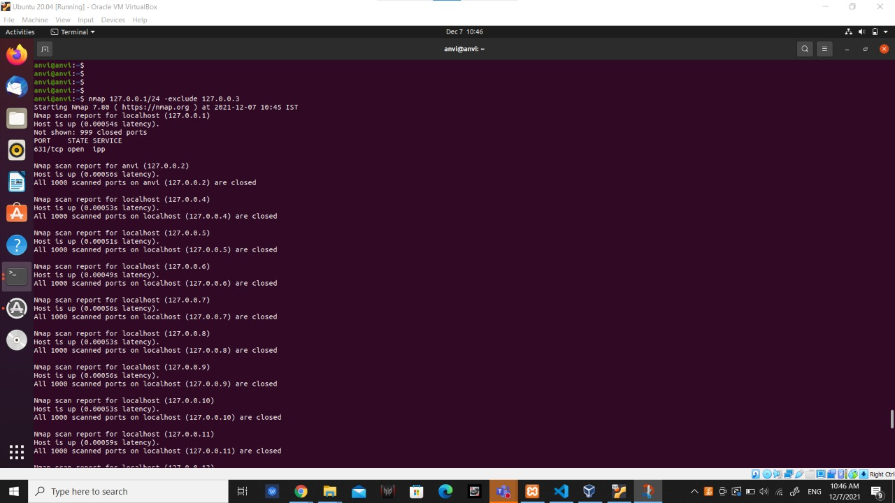

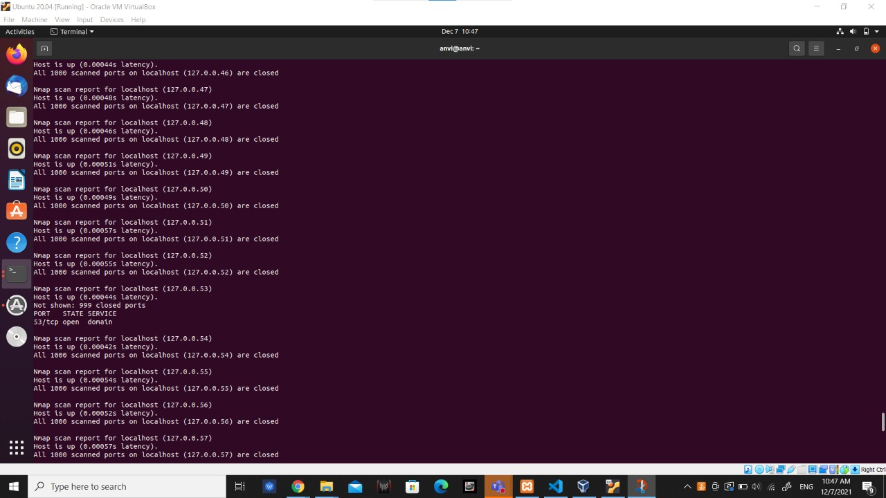

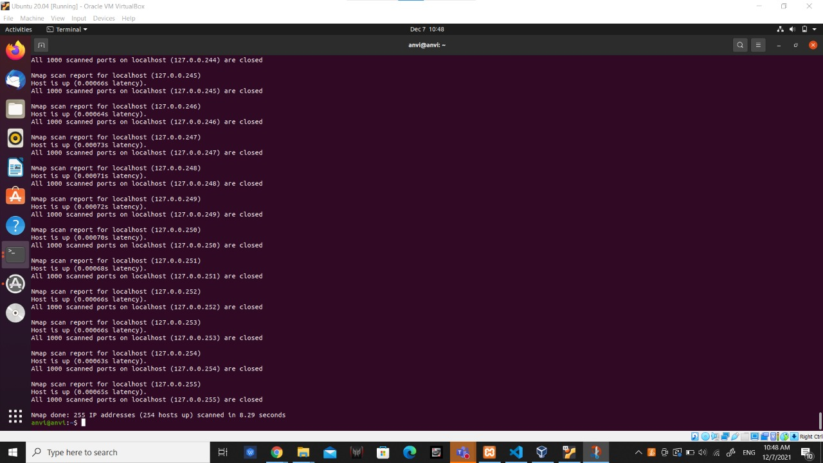

e)nmap -sF 127.0.0.1

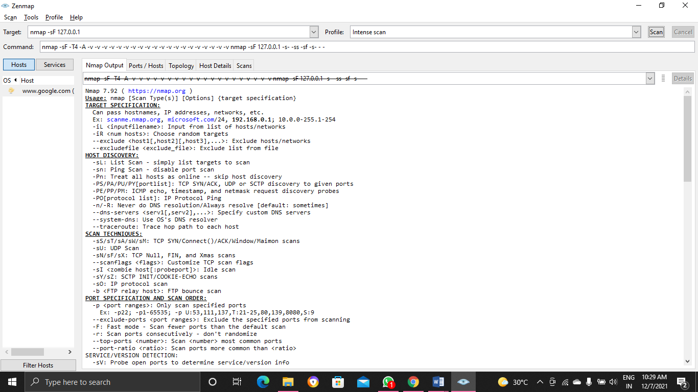

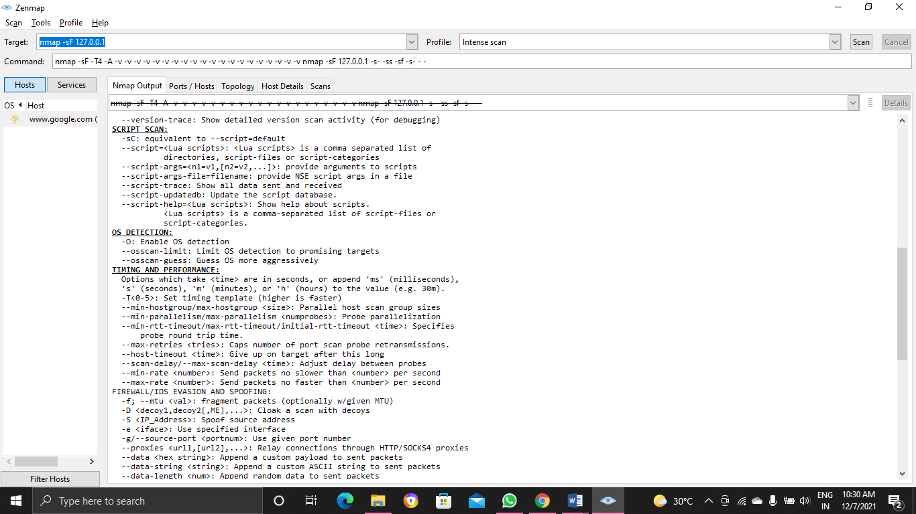

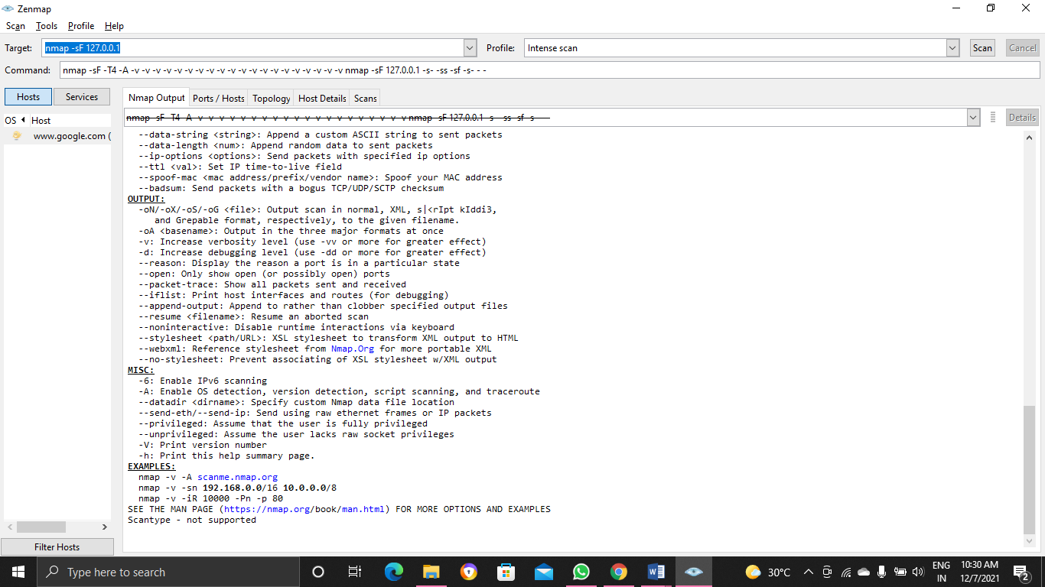

2)

Aim and Psuedocode:

To access router filters and access control Lists with ports s20 and 53

Psuedo code:

* To view a policy access control list, click a domain’s name from the Domains pane in the Policy
* Administration window and select the Access Control Rules tab. In the Search Results table, click the view access control lists icon .
* The View Access Control Lists window opens.
* Multiple View Access Control Lists windows can be opened to allow you to compare lists for different object types and life cycle states.

to acess file connected to router :Click Start > All Programs > Accessories > Run.

Type \\ IP address of the router (default is 192.168.0.1)

Example- \\192.168.0.1.

Click OK.

If you are prompted to enter a Username and Password, enter the credentials that you use to log in to the router's web-based configuration utility.

**Program and Output**

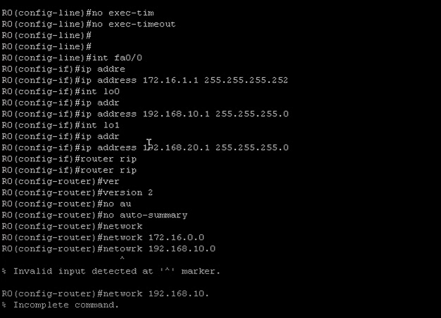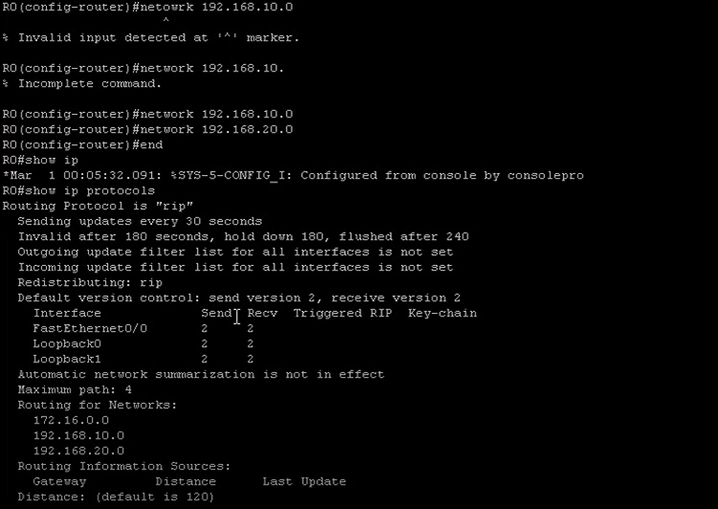

3)

Aim & Psuedocode:

Our aim is to check if Spoofing of Source Address is possible or not. If possible we have to demonstrate.

IP address spoofing, or IP spoofing, is the forging of a source IP address field in IP packets with the purpose of concealing the identity of the sender or impersonating another computing system. Fundamentally, source IP spoofing is possible because Internet global routing is based on the destination IP address.

Yes we can spoof IP address

The most common forms of spoofing are:

* **DNS server spoofing** – Modifies a DNS server in order to redirect a domain name to a different IP address. It’s typically used to spread viruses.
* **ARP spoofing** – Links a perpetrator’s MAC address to a legitimate IP address through spoofed ARP messages. It’s typically used in denial of service (DoS) and man-in-the-middle assaults.
* **IP address spoofing** – Disguises an attacker’s origin IP. It’s typically used in DoS assaults.

Program and Output:

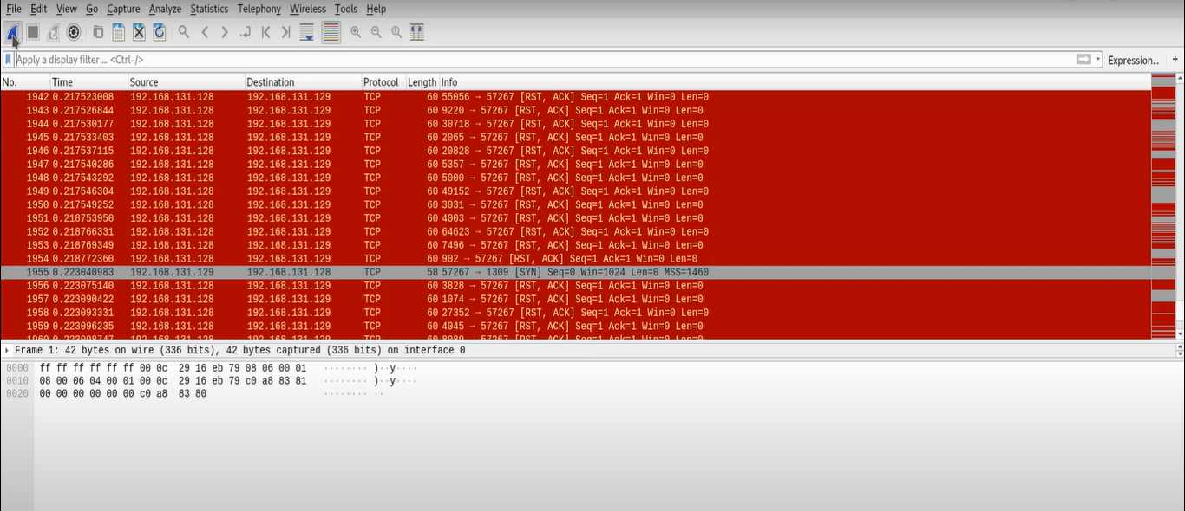

These are list of various IP sources

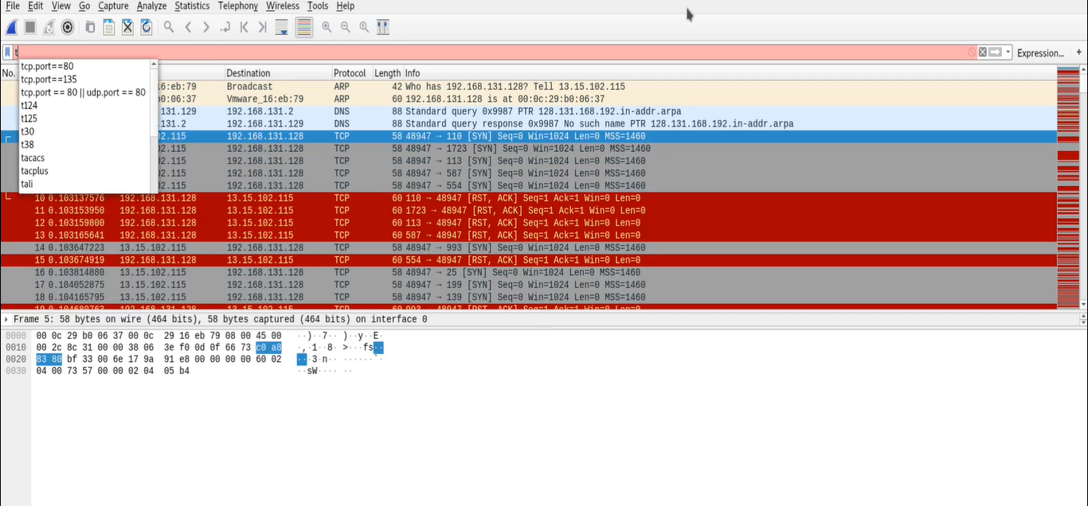

We are considering a particular IP address among all these for spoofing.

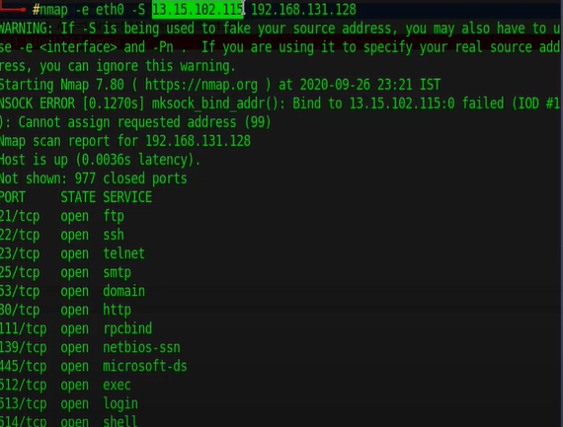

Spoofing a particular IP address whose source addr is:13.15.102.115 and Destination addr :192.168.131.128

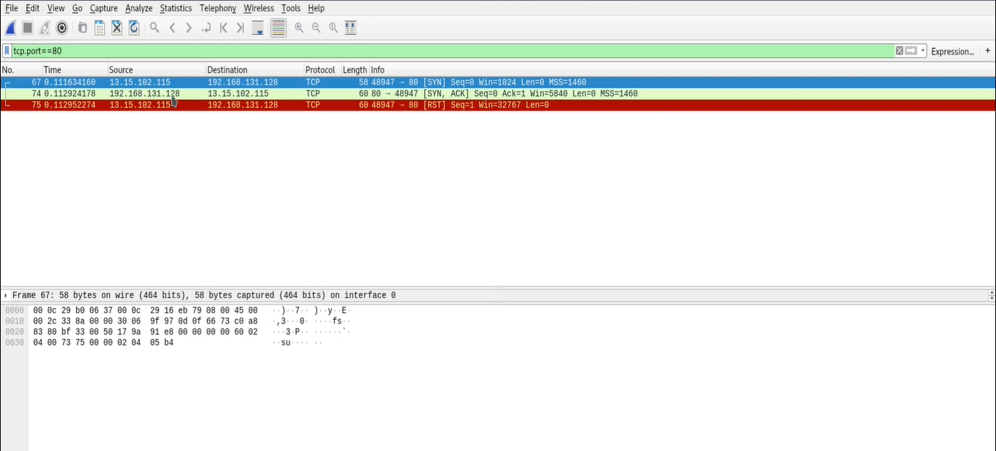

Considering IP sources whose tcp==80

We can see that there are 2 same Ip sources Request generated from Fake IP address in blue color line.